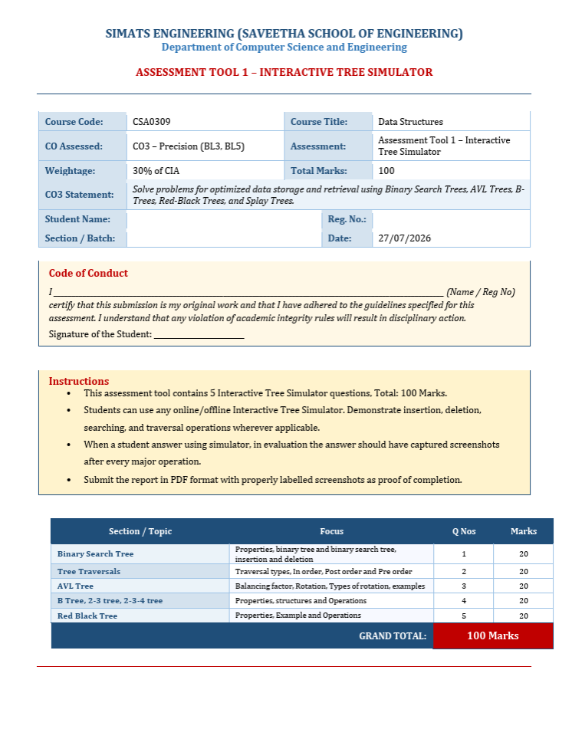

K.KAVIYA 192521262
1

Kaviya. K

k.kaviya

- Construct a Binary Search Tree (BST) by inserting the following keys: 40, 20, 10, 30, 60, 50, 70
Perform:
a. In order Traversal
b. Search for 70
c. Delete 50
d. Display the final BST.

- In order Traversal

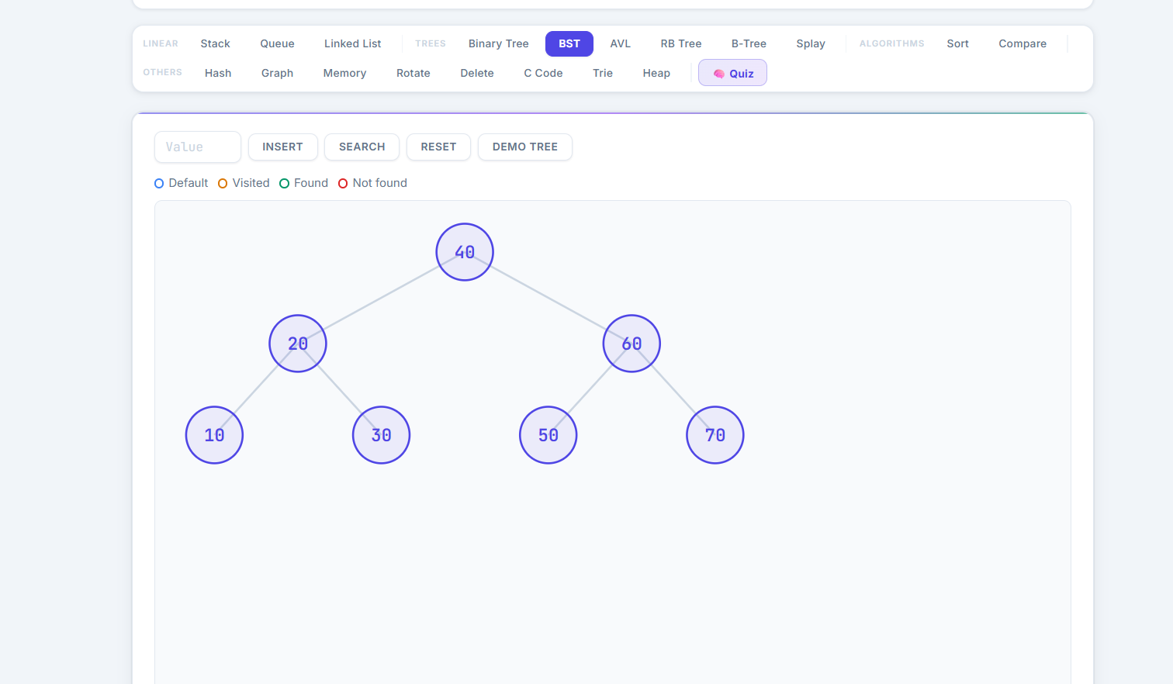

b. Search for 70
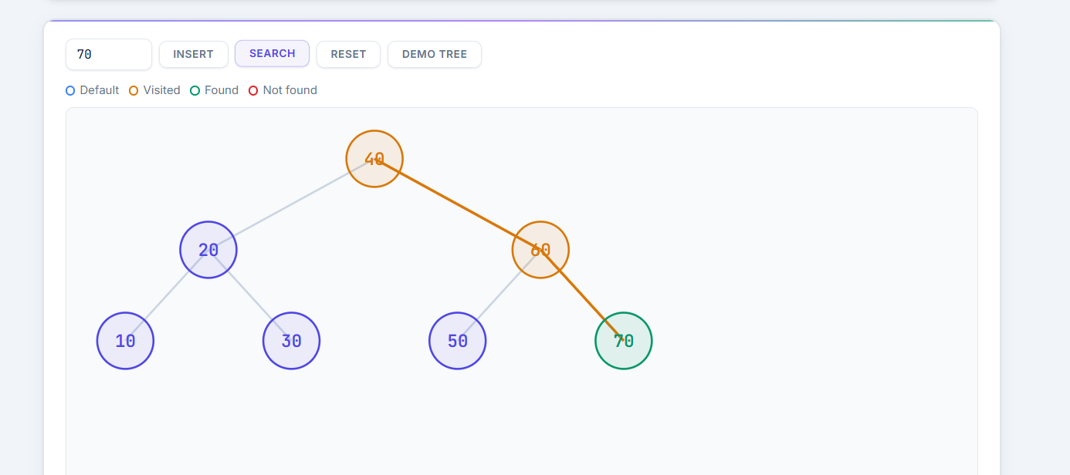

c. Delete 50
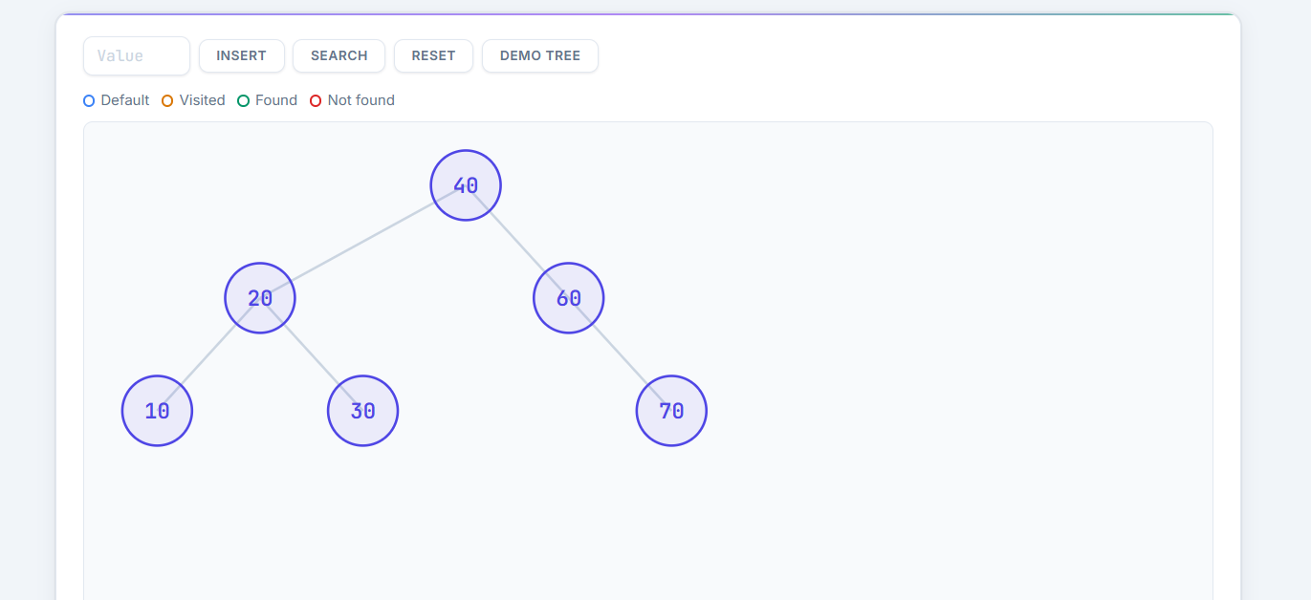

d. Display the final BST
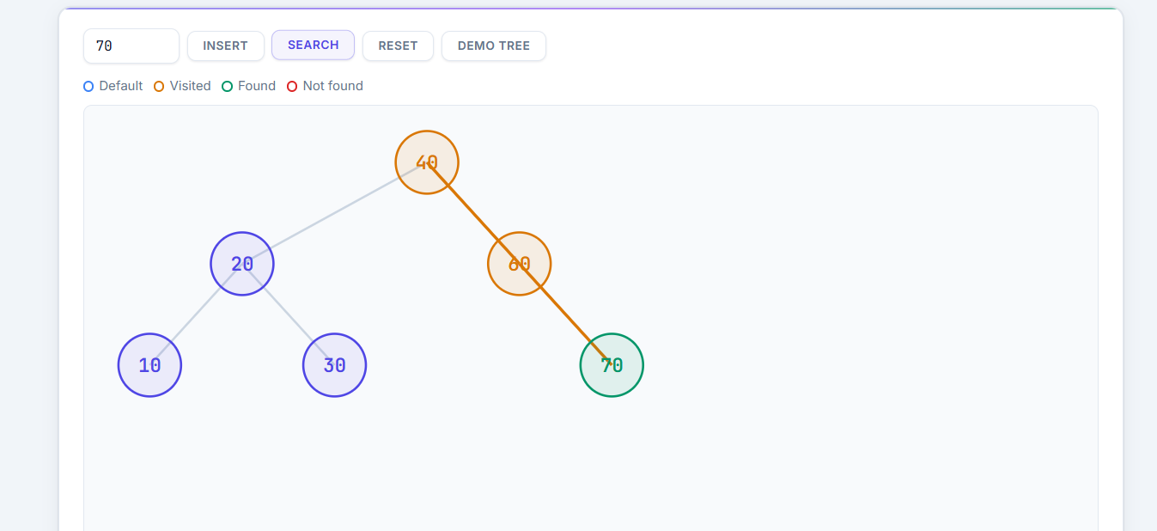

2. Complete Tree Traversals by Inserting 55,35,75,25,45,65,85. Find all the traversals.
a. Inorder
b. Preorder
c. Postorder

a. Inorder
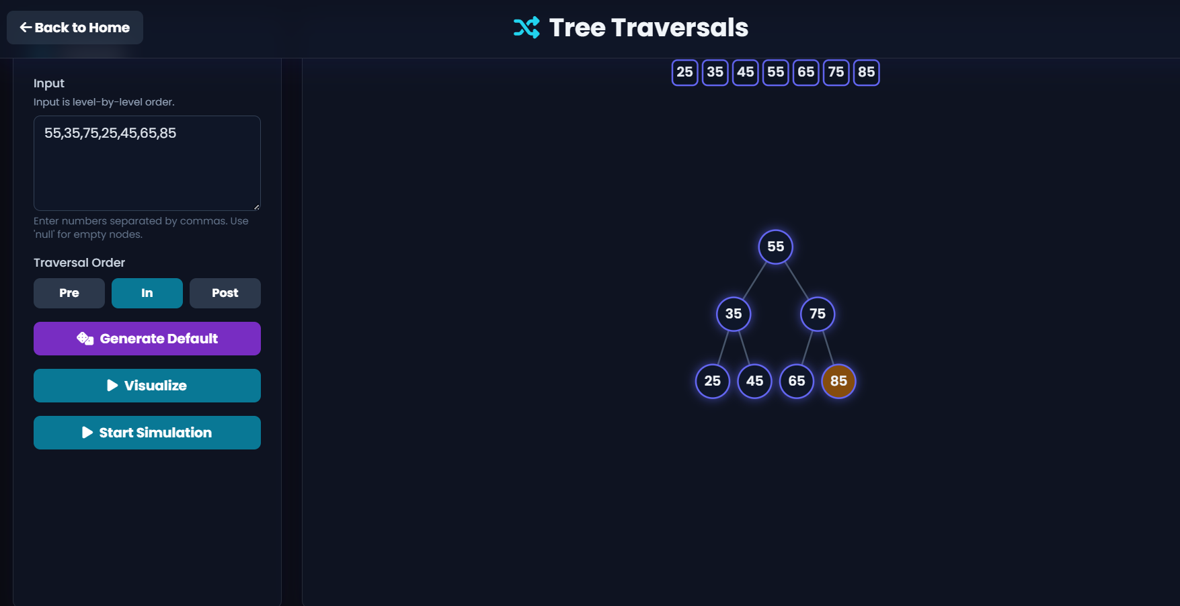

b. Preorder
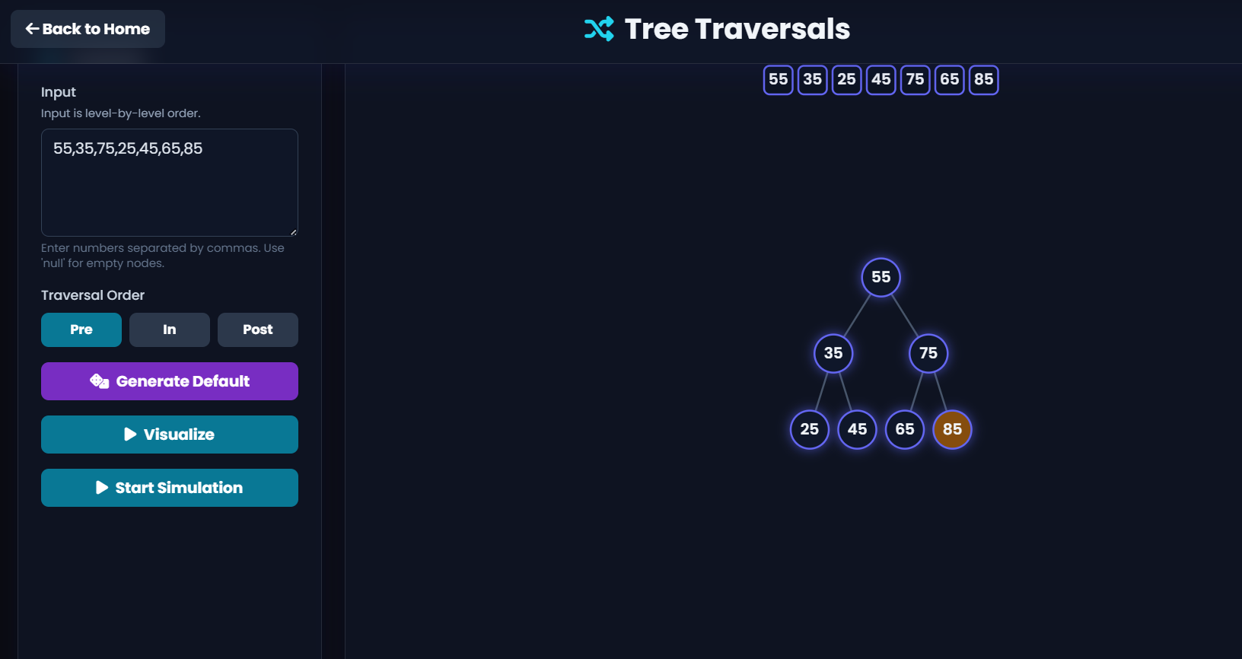

c. Postorder
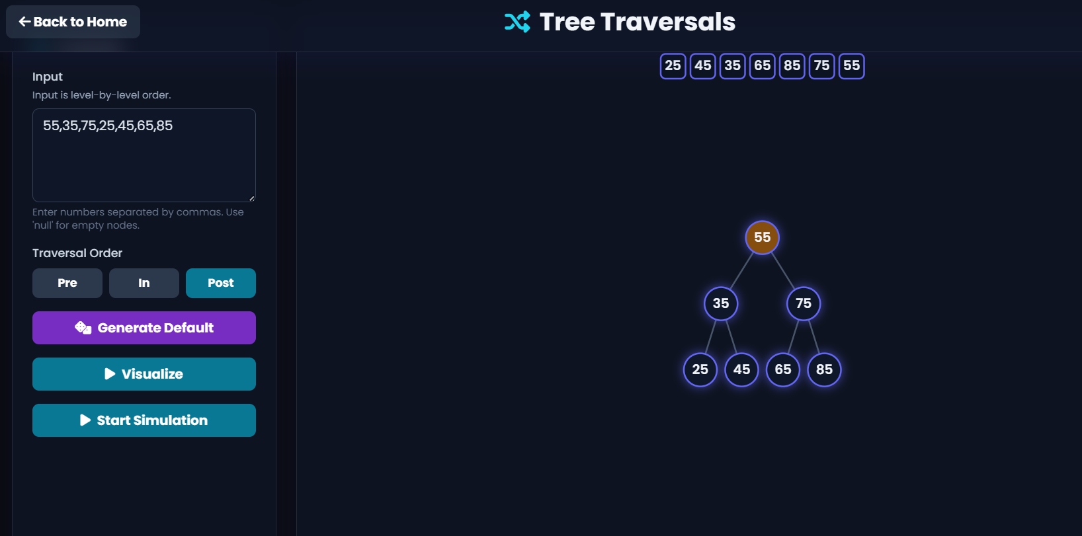

3. Insert 40, 20, 60, 10, 30, 50, 70, 5 into an AVL Tree. Determine the balance factor of every node before and after balancing.
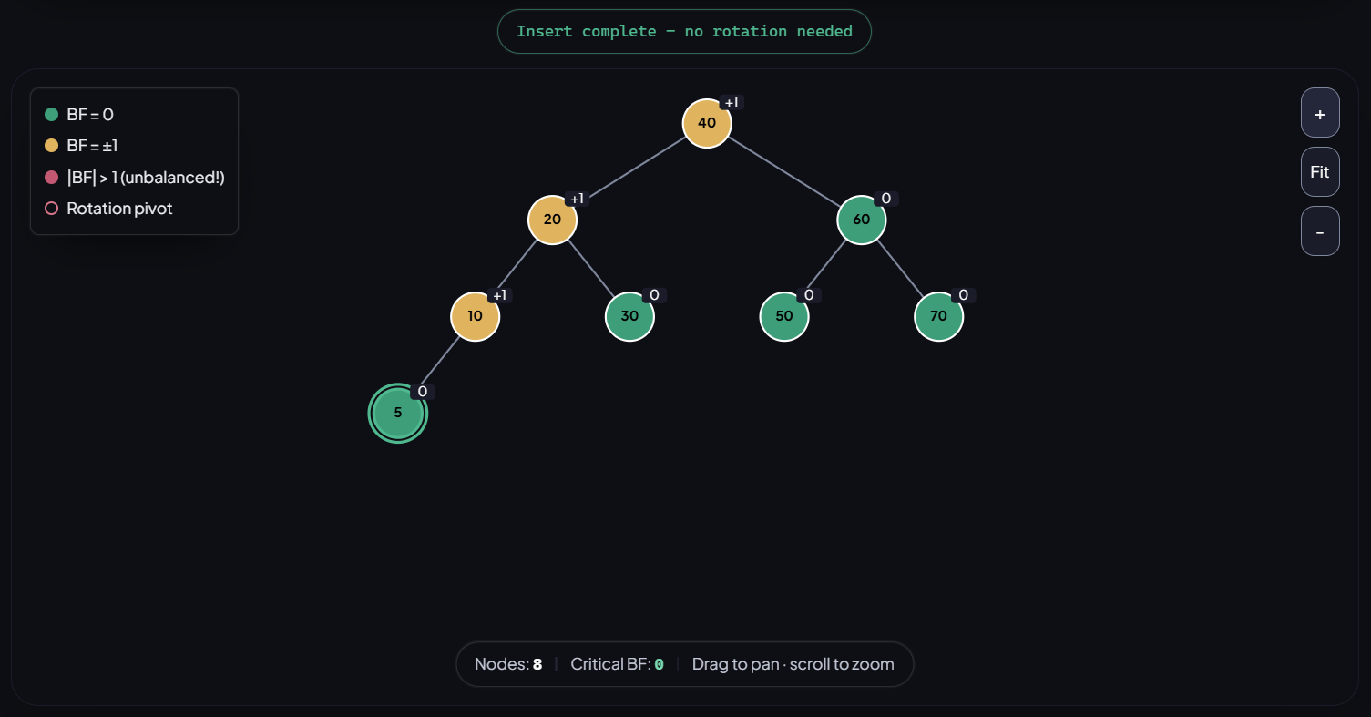

4. Construct a B-Tree of order 3 by inserting 10, 20, 30, 40, 50.
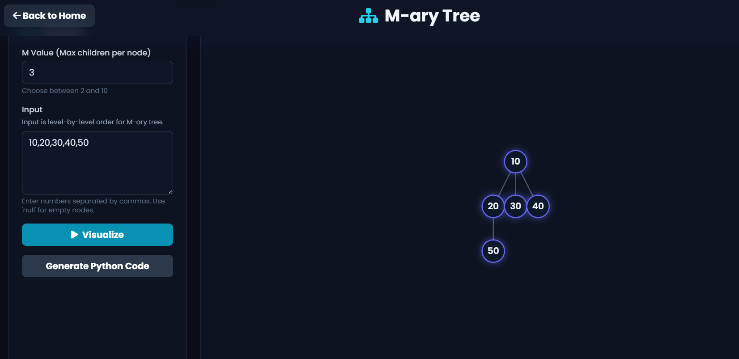

5. Construct a Red-Black Tree using 50, 40, 60, 30, 45, 55, 70, 20. Delete 30 and analyze how Red-Black properties are restored.
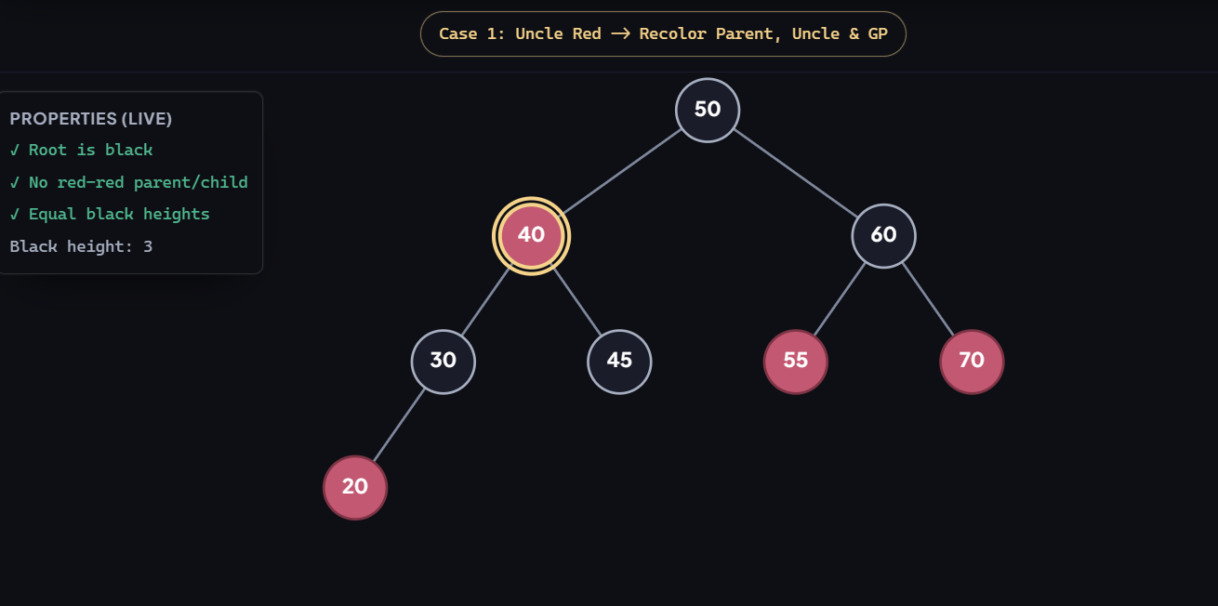

Delete 30
